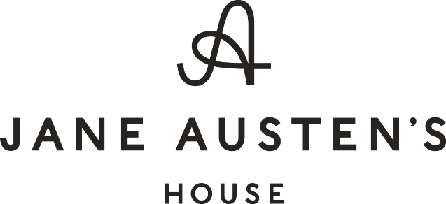

Returns Form

(Complete and return this form only if you wish to withdraw from the contract)
To Jane Austen’s House Museum, Winchester Road, Chawton, Hampshire GU34 1SD
01420 83262
enquiries@janeaustens.house
I/We [*] hereby give notice that I/We [*] cancel my/our [*] contract of sale of the following goods [*]/for the supply of the following service [*],
Ordered on [*]/received on [*],
Name of consumer(s),
Address of consumer(s),
Signature of consumer(s) (only if this form is notified on paper),
Date

