Volunteering at

Application
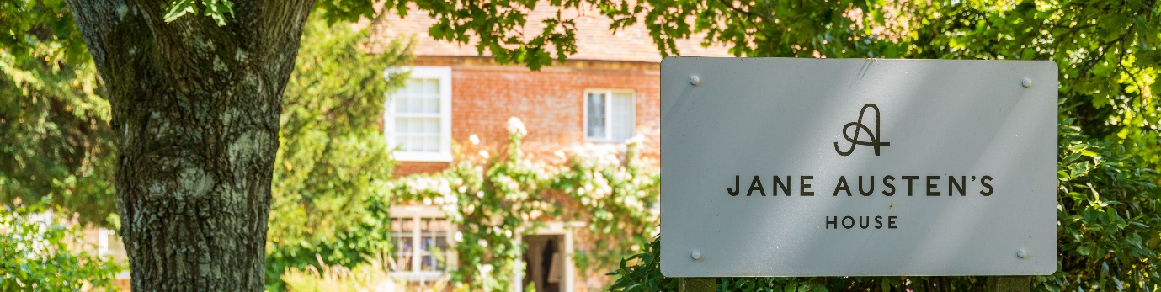
Thank you so much for your interest in volunteering at JAH. Please take a few minutes to complete the below form so we can learn a bit more about you.
If you have any questions about completing this form or about your volunteer application, please contact susan.rayner@janeaustens.house
Please indicate which role/s you’re interested in… (tick all that apply)
House Steward
Visitor Welcomer
Conservation Cleaner
Education Support
Collection Support
Event Support
Gardener
Regency Stitcher

Your details…
Name
Address

Email address
Contact number
Over 18?
A bit more about you…
What interests you most about volunteering at Jane Austen’s House?

With your preferred role in mind, please tell us about any relevant experience you have.

Please tell us about your hobbies, interests, or special skills relevant to volunteering here.

Are there any health concerns that you may need support with?

We may need to carry out a DBS check or request references to enable you to work with children or vulnerable adults. Do you have any objection to this?

Please supply the name and email address of one referee who knows you well

Lastly, please tell us about your availability. How much time you would like to volunteer? (Please refer to role descriptions for minimum time requirements)

Please return completed applications to susan.rayner@janeaustens.house
Thank you

March 2023

